**EMOTION BASED MUSIC PLAYER**

**A PROJECT REPORT**

Submitted to

**Jawaharlal Nehru Technological University Kakinada, Kakinada**

in partial fulfillment for the award of the degree of

**Bachelor of Technology**

**in**

**COMPUTER SCIENCE AND ENGINEERING**

Submitted by

**KOPPARAPU VENKATA VASAVI (17KN1A0568)**

**MANTHA SAI ADITYA (17KN1A0587)**

**NAIDU RUPA SREE (17KN1A0598)**

**NANDYALA KARTHIK NAIDU (17KN1A05A2)**

**SAI PRAKASH PATHURU (17KN1A05B1**)

Under the esteemed guidance of

**M.SPANDANA**

**Designation of the guide, CSE Department**



**DEPARTMENT OF COMPUTER SCIENCE AND ENGINEERING**

**NRI INSTITUTE OF TECHNOLOGY**

**(Approved by AICTE, Permanently Affiliated to JNTUK, Kakinada)**

**(Accredited by NAAC with ‘A’ Grade, ISO 9001: 2015 Certified)**

**Pothavarappadu (V), Agiripalli (M), Krishna Dist, PIN: 521212, A.P, India.**

**2017-2021**

 NRI INSTITUTE OF TECHNOLOGY

(Approved by AICTE, Permanently Affiliated to JNTUK, Kakinada) Accredited by NBA (CSE, ECE & EEE), Accredited by NAAC with ‘A’ Grade ISO 9001: 2015 Certified Institution Pothavarappadu (V), (Via) Nunna, Agiripalli (M), Krishna Dist, PIN: 521212, A.P, India

**Certificate**

This is to certify that the Project entitled “**EMOTION BASED MUSIC PLAYER**” is a bonafide work carried out by Name of **Kopparapu Venkata Vasavi (17KN1A0568), Mantha Sai Aditya (17KN1A0587), Naidu Rupa Sree (17KN1A0598), Nandyala Karthik Naidu (17KN1A05A2), Sai Prakash Pathuru (17KN1A05B1)** in partial fulfillment for the award of the degree of Bachelor of Technology in **Computer Science & Engineering of Jawaharlal Nehru Technological University Kakinada**, Kakinada during the year 2020-2021.

**(M.Spandana) (Dr.D.Suneetha) Project Guide Head of the Department**

**EXTERNAL EXAMINER**

DECLARATION

We hereby declare that the project report titled “A User-Centric Machine Learning Framework For Cyber Security Operation Center” is a bonafide work carried out in the Department of Computer Science and Engineering, NRI Institute of Technology, Agiripalli,Vijayawada, during the academic year 2020-2021, in partial fulfilment for the award of the degree of Bachelor of Technology by JNTU Kakinada.

We further declare that this dissertation has not been submitted elsewhere for any Degree.

**17KN1A0568**

**17KN1A0587**

**17KN1A0598**

**17KN1A05A2**

**17KN1A05B1**

**Acknowledgment**

We take this opportunity to thank all who have rendered their full support to my work. The pleasure, the achievement, the glory, the satisfaction, the reward, the appreciation and the construction of my project cannot be expressed with a few words for their valuable suggestions.

We are grateful to our Project Guide **M. Spandana, Associate professor** for rendering the valuable suggestions and extended her support to complete the project successfully.

We are expressing our heartfelt thanks to **Head of the Department, Dr. D. Suneetha garu** for her continuous guidance for completion of our Project work.

We are extending our sincere thanks to **Dean of the Department, Dr. K. V. Sambasiva Rao garu** for his continuous guidance and support to complete our project successfully.

We are thankful to the **Principal, Dr. C. Naga Bhaskar garu** for his encouragement to complete the Project work.

We are extending our sincere and honest thanks to the **Chairman, Dr. R. Venkata Rao garu & Secretary, Sri K. Sridhar garu** for their continuous support in completing the Project work.

Finally, we thank the Administrative Officer, Staff Members, Faculty of Department of CSE, NRI Institute of Technology and our friends, directly or indirectly helped us in the completion of this project.

**17KN1A0568**

**17KN1A0587**

**17KN1A0598**

**17KN1A05A2**

**17KN1A05B1**

**ABSTRACT**

This project Emo player (an emotion based music player) is a novel approach that helps the user to automatically play songs based on the emotions of the user. It recognizes the facial emotions of the user and plays the songs according to their emotion. The emotions are recognized using a machine learning method Support Vector Machine (SVM)algorithm. SVM can be used for classification or regression problems. It finds an optimal boundary between the possible outputs. The training dataset which we used is Olivetti faces which contain 400 faces and its desired values or parameters. The webcam captures the image of the user. It then extract the facial features of the user from the captured image. The training process involves initializing some random values for say smiling and not smiling of our model, predict the output with those values, then compare it with the model's prediction and then adjust the values so that they match the predictions that were made previously. Evaluation allows the testing of the model against data that has never been seen and used for training and is meant to be representative of how the model might perform when in the real world. According to the emotion, the music will be played from the predefined directories.

**INDEX**

**I. List of Figures**

### **1.Introduction**

1.1 Introduction to project

1.2 Problem Definition

1.3 Solution for problem Definition

1.4 Methodology used

**2. Literature Review**

**3. System Analysis**

3.1 Existing System

3.2 Proposed System

**4. Requirement**

4.1 Functional Requirement

4.2 Non-Functional Requirement

4.3 constraints

4.4 Hardware and Software Requirements

**5. Proposed Design**

5.1 Data Flow Diagram

5.2 Use case Diagram

5.3 Class Diagram

5.4 Sequence Diagram

5.5 Flowchart Diagram

**6. Implementation**

6.1 Implementation Steps

**7. Testing**

7.1 Unit Testing

7.2 Integration Testing

7.3 Acceptance Testing

7.4 Functional Testing

7.5 System Testing

7.6 White Box Testing

7.7 Black Box Testing

7.8 Alpha Testing

7.9 Beta Testing

**8. Result Analysis**

8.1 Output Screenshots

8.2 Observation and Analysis

**9. Conclusion**

9.1 Results and Discussion

9.2 Conclusion

9.3 Future Scope

**References**

**1.List of Figures**

**Introduction**

* 1. **Introduction to Project**

Music plays a very important role in enhancing an individual‘s life as it is an important medium of entertainment for music lovers and listeners and sometimes. In today‘s world, with ever increasing advancements in the field of multimedia and technology, various music players have been developed with features like fast forward, reverse, variable playback speed (seek & time compression),local playback, streaming playback with multicast streams and including volume modulation, genre classification etc. Although these features satisfy the user‘s basic requirements, yet the user has to face the task of manually browsing through the playlist of songs and select songs based on his current mood and behaviour. That is the requirement of an individual, a user suffers through the need and desire of browsing through his playlist, according to his mood and emotions. Using traditional music players, a user had to manually browse through his playlist and select songs that would match his mood and emotional experience. This task was labour intensive and an individual often faced the dilemma of landing at an appropriate list of songs.

Emotions play a vital role in our day-to-day life and facial expressions are the most natural way of relaying them. The ability to understand human emotions is desirable for human-computer interaction. In the past decade, considerable amounts of research have been done on emotion recognition from voice, visual behaviour. Very good progresses have been achieved in this field, and several commercial products have been developed, such as smile detection in camera. Emotion is a subjective response to the outer stimulus. A facial expression is a discernible manifestation of the emotive state, cognitive activity, motive, and psychopathology of a person. Homo sapiens have been blessed with an ability to interpret and analyse an individual’s emotional state.

Classification technique can be used to classify the user’s emotions by capturing a picture of the user. The captured image is classified based on an inbuilt dataset and by support Vector Machine Algorithm.

SVM can be used for classification or regression problems. It finds an optimal boundary between the possible outputs. The training dataset which we used is Olivetti faces which contain faces and its desired values or parameters.

**1.2 Problem Definition**

Now-a-days there are many music players that play songs when the users add a playlist and save music into that playlist. But if the user is in a bad mood and he wants sad music he must again create playlist and add sad songs to the playlist.

**1.3 Solution for Problem Definition**

**1.4 Methodology used**

**Technique involved for Face Detection**

**OpenCV:** OpenCV is a Python open-source library, which is used for computer vision in Artificial intelligence, Machine Learning, face recognition, etc. In OpenCV, the CV is an abbreviation form of a computer vision, which is defined as a field of study that helps computers to understand the content of the digital images such as photographs and videos. The purpose of computer vision is to understand the content of the images. It extracts the description from the pictures, which may be an object, a text description, and three-dimension model, and so on. For example, cars can be facilitated with computer vision, which will be able to identify and different objects around the road, such as traffic lights, pedestrians, traffic signs, and so on, and acts accordingly.

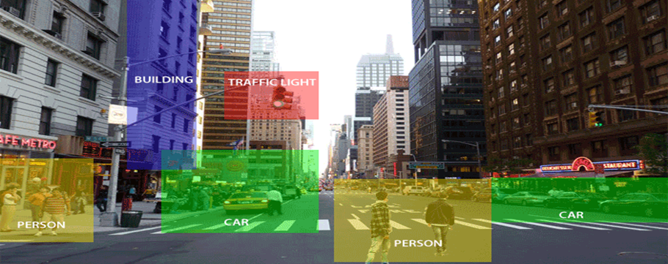

Computer vision allows the computer to perform the same kind of tasks as humans with the same efficiency. There are a two main task which are defined below:

Object Classification - In the object classification, we train a model on a dataset of particular objects, and the model classifies new objects as belonging to one or more of your training categories.

Object Identification - In the object identification, our model will identify a particular instance of an object - for example, detecting three faces in an image.

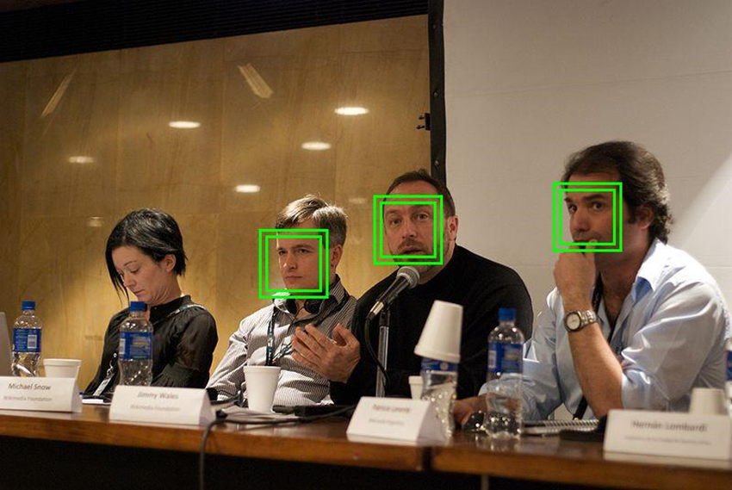

**Technique involved for Classifying and Detecting**

**Support vector Machine (SVM):** Support Vector Machine or SVM is one of the most popular Supervised Learning algorithms, which is used for Classification as well as Regression problems. However, primarily, it is used for Classification problems in Machine Learning.

The goal of the SVM algorithm is to create the best line or decision boundary that can segregate n-dimensional space into classes so that we can easily put the new data point in the correct category in the future. This best decision boundary is called a hyperplane.

SVM chooses the extreme points/vectors that help in creating the hyperplane. These extreme cases are called as support vectors, and hence algorithm is termed as Support Vector Machine.

**Example:** SVM can be understood with the example that we have used in the KNN classifier. Suppose we see a strange cat that also has some features of dogs, so if we want a model that can accurately identify whether it is a cat or dog, so such a model can be created by using the SVM algorithm. We will first train our model with lots of images of cats and dogs so that it can learn about different features of cats and dogs, and then we test it with this strange creature. So as support vector creates a decision boundary between these two data (cat and dog) and choose extreme cases (support vectors), it will see the extreme case of cat and dog. On the basis of the support vectors, it will classify it as a cat. Consider the below diagram:

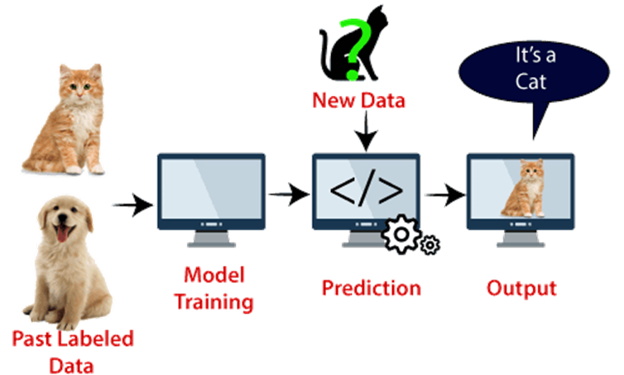

**LITERATURE SURVEY**

**2.LITERATURE SURVEY**

**Problems**

Using traditional music players, a user had to manually browse through his playlist and select songs that would soothe his mood and emotional experience. In today‘s world, with ever increasing advancements in the field of multimedia and technology, various music players have been developed with features like fast forward, reverse, variable playback speed (seek & time compression),local playback, streaming playback with multicast streams and including volume modulation, genre classification etc. Although these features satisfy the user‘s basic

requirements, yet the user has to face the task of manually browsing through the playlist of songs and select songs based on his current mood and behaviour. That is the requirements of an individual, a user sporadically suffered through the need and desire of browsing through his playlist, according to his mood and emotions.

**Objectives**

The Main objective of this particular paper is that it helps the user to automatically play songs based on the emotions of the user. It recognizes the facial emotions of the user and plays the songs according to their emotion. The emotions are recognized using a machine learning method Support Vector Machine (SVM)algorithm. The human face is an important organ of an individual‘s body and it especially plays an important role in extraction of an individual‘s behaviours and emotional state. The webcam captures the image of the user. It then extract the facial features of the user from the captured image. Facial expression categorized into 2, smiling and not smiling. According to the emotion, the music will be played from the predefined directories.

**System Analysis**

**3.System Analysis**

**3.1 Exsting System**

The features available in the existing Music players present in computer systems are as follows: i. Manual selection of Songs.

ii. Party Shuffle.

iii. Playlists.

iv. Music squares where user has to classify the songs manually according to particular emotions for only four basic emotions.

Those are Passionate, Calm, Joyful and Excitement. Using traditional music players, a user had to manually browse through his playlist and select songs that would soothe his mood and emotional experience. In today‘s world, with ever increasing advancements in the field of multimedia and technology, various music players have been developed with features like fast forward, reverse, variable playback speed (seek & time compression),local playback, streaming playback with multicast streams and including volume modulation, genre classification etc. Although these features satisfy the user‘s basic requirements, yet the user has to face the task of manually browsing through the playlist of songs and select songs based on his current mood and behaviour. That is the requirements of an individual, a user sporadically suffered through the need and desire of browsing through his playlist, according to his mood and emotions.

Limitations of Existing System:

i. It requires the user to manually select the songs.

ii. Randomly played songs may not match to the mood of the user.

iii. User has to classify the songs into various emotions and then for playing the songs user has to manually select a particular emotion.

**3.2 Proposed System**

Here wepropose a Emotion based music player(Emo Player).Emo player is an music player which play songs according to the emotion of the user.. It aims to provide userpreferred music with emotion awareness. Emo player is based on the idea of automating much of the interaction between the music player and its user. The emotions are recognized using a machine learning method Support Vector Machine (SVM)algorithm. In machine learning, support vector machines are supervised learning models with associated learning algorithms that analyse data used for classification and regression analysis. It finds an optimal boundary between the possible outputs. The training dataset which we used is Olivetti faces which contain 400 faces and its desired values or parameters. The webcam captures the image of the user. It then extract the facial features of the user from the captured image. The training process involves initializing some random values for say smiling and not smiling of our model, predict the output with those values, then compare it with the model's prediction and then adjust the values so that they match the predictions that were made previously. Evaluation allows the testing of the model against data that has never been seen and used for training and is meant to be representative of how the model might perform when in the real world. According to the emotion, the music will be played from the predefined directories.

Advantages of Proposed System:

i. Users don’t want to select song manually.

ii. No need of playlist.

iii. Users don’t want to classify the songs based on the

emotions.

**3.3 Analysis Model**

The model followed is the WATERFALL MODEL, which states that the phases are organized in a linear order.

Classical waterfall model is the basic software development life cycle model. It is simple but idealistic. This model considers that each phase can be started after completion of the previous phase. An output of the previous phase will be the input to the next phase. Thus, the development process can be considered as a sequential flow in the waterfall. Here, the phases do not overlap with each other. This model works well for smaller projects and projects where requirements are well understood.

Let us know about each of these phases in brief details:

1.Feasibility Study: The feasibility study involves understanding the problem and then determine the various possible strategies to solve the problem. The best solution is chosen and all the other phases are carried out as per this solution strategy.

Requirements analysis and specification: The aim of the requirement analysis and specification phase is to understand the exact requirements of the customer and document them properly. This phase consists of two different activities.

Requirement gathering and analysis: Firstly all the requirements regarding the software are gathered from the customer and then the gathered requirements are analyzed.

Requirement specification: These analyzed requirements are documented in a software requirement specification (SRS) document.

2. Design: The aim of the design phase is to transform the requirements specified in the SRS document into a structure that is suitable for implementation in some programming language.

3. Coding: In coding phase software design is translated into source code using any suitable programming language.

4. Testing: Testing is the process of evaluating a software item to detect differences between a given input and expected output and that should be done during the development process. Also to assess the feature of A software item. Testing assesses the quality of the product.

Verification: Verification is the process to make sure the product satisfies the conditions imposed at the start of the development phase.

Validation: Validation is the process to make sure the product satisfies the specified requirements at the end of the development phase.

6. Maintenance: Maintenance is the most important phase of a software life cycle. The effort spent on maintenance is 60% of the total effort spent to develop full software. This is required to correct errors that were not discovered during the product development phase and to enhance the functionalities of the system based on the customer’s request.

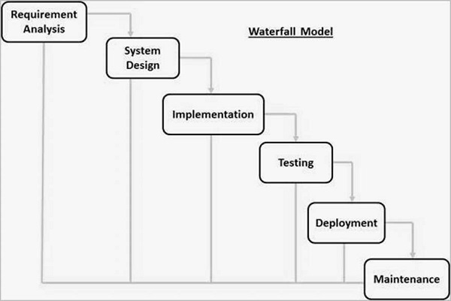

Figure 1.1Phases of SDLC

**Fig: 1.1 Phases of SDLC**

**4.Feasibility Study**

A Feasibility Study is a preliminary study undertaken before the real work of a project starts to ascertain the likelihood of project success. It is an analysis of possible alternative solutions to a problem and a recommendation on the best alternative.

4.1 Technical feasibility

4.2 Economic feasibility

4.3 Operational feasibility

**4.1 Technical Feasibility**

The technical feasibility infers whether the proposed system can be developed considering the technical issues like availability of the necessary technology, technical capacity, adequate response, and sensibility.

The project is decided to build using java. Java Environment is designed for use in a distributed environment of the internet and for the professional programmer, it is easy to learn and use effectively. As the developing organization has all the resources available to build the system, therefore, the proposed system is technically feasible.

**4.2 Economic Feasibility**

It is defined as the process of assessing the benefits and costs associated with the development of the project. A proposed system, which is both operationally and technically feasible, must be a good investment for the organization.

With the proposed system the users are greatly benefited as the users can be able to use the browsing capabilities on tiny devices or mobile devices. This proposed system does not need any additional software and high system configuration. Hence the proposed system is economically feasible.

**4.3. Operational Feasibility**

Operational feasibility is defined as the process of assessing the degree to which a proposed system solves business problems or takes advantage of business opportunities.

The system is self-explanatory and doesn’t need any extra sophisticated training. The system has been built by concentrating on the graphical user interface concepts. The application can be handled very easily with a novice user. The overall time that a user needs to get trained is less than one hour. As the software that is used for developing this application is very economical and is readily available in the market. Therefore the proposed system is operationally feasible.

**Requirements**

**4.1 Functional Requirements**

Functional requirements are statement of services the system should provide, how the system should react to particular inputs and how the system should behave in particular situation.:

1. The dataset train by support vector classifier.
2. Machine learns support vector classification using support vector machine.
3. Learn and identify image capture by web cam.

**4.2 Non-Functional Requirements**

In systems engineering and requirements engineering, a non-functional requirement is a requirement that specifies criteria that can be used to judge the operation of a system, rather than specific behaviors. This should be contrasted with functional requirements that define specific behavior or functions. The plan for implementing non-functional requirements is detailed in the system architecture. Non-functional requirements define how a system is supposed to be. Functional requirements are usually in the form of "system shall do ".

**4.2.1 Reliability:**

Stress detecting System shall be available 24 hours a day for application users.

**4.2.2 Security:**

Since the system needs access on the user's data which is in the form of text, visual,images etc. System shall not misuse or spread the data.

**4.2.3 Performance:**

Stress detecting System shall not take longer than 30 seconds to respond to a page request client; when using a standard internet connection.

**4.2.4 Compatibility:**

Stress detecting System application will be supported on current equipment such as desktop computers, laptops, printers, smartphones etc.

**4.2.5 Interface:**

Stress detecting System shall be accessible through a web browser such as Internet Explorer, Google Chrome or Mozilla Firefox. System shall provide printer friendly outputs of reports so that users can have easy to read printouts of the reports.

**4.3 Constraints**

**4.4 hardware and Software Requirements**

Expert systems building tools (shells) are programs that make the job of building expert systems easier. Thus, tools are those programs which aid you to develop your own AI application. It has been claimed that these tools perform the development of expert systems in less time.

**Hardware Requirements:**

➢ Processor – Intel i3 or above

➢ RAM - 4 GB (min)

➢ Hard Disk - 3 GB

➢ Key Board - Standard Windows Keyboard

➢ Mouse - Two or Three Button Mouse

➢ Monitor - SVGA

**Software Requirements:**

➢ Operating System - Windows 7 or above

➢ Coding Language -Python)

➢ Front End - HTML

➢ Back End – Java Script